Nama : Ziyan Fadilla Saporette

NIM :18090058

Kelas : 5A

PRAKTIKUM 5

1. Source Code

Autoload.php => application / config.php

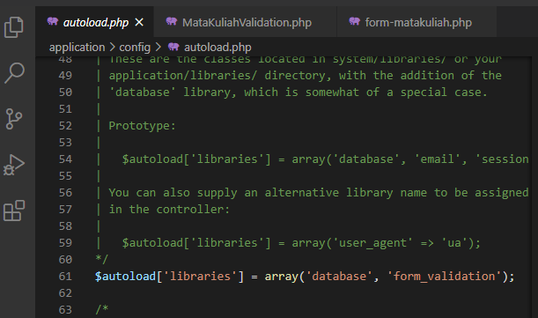

MataKuliahValidation.php => application / controller

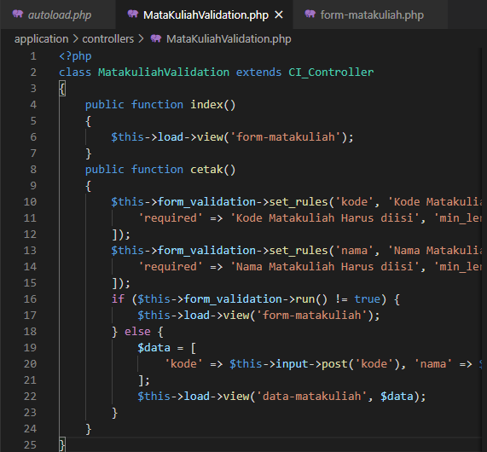

form-matakuliah.php => application / views

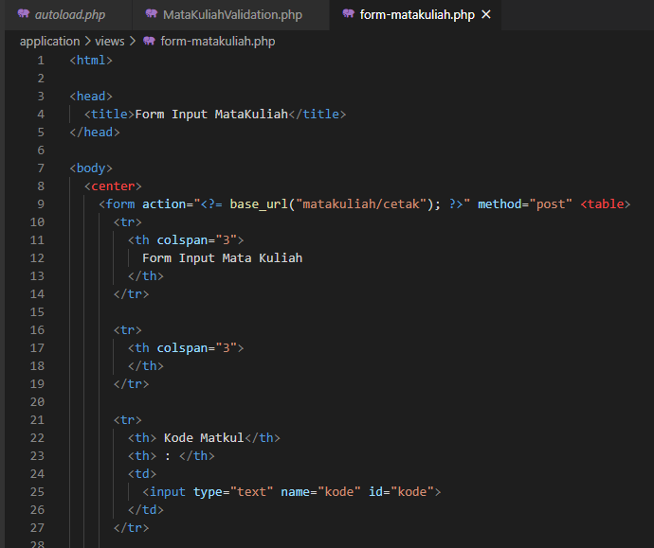

1. URL

<http://localhost:8090/pustaka_zyn/index.php/MataKuliahValidation>

1. Capture Hasil

